Lesson Agenda:

1. What is Image?Types of Image.
2. What is Digital Image Proceessing.
3. **Write the Steps of Digital Image Processing?**
4. **Write the** Applications of Digital Image Processing

### **Write the advantages and disadvantages of Digital Image Processing?**

Topic - 1: Introduction

1.What is an image?Types of images.

* an image can be defined by a two-dimensional array specifically arranged in rows and columns.
* 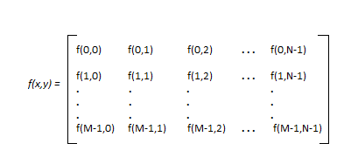
* The amplitude of f is called the intensity or the gray level a at point (x,y)
* Every element of this matrix is called image element , picture element , or pixel.

*Digital image processing covers low and high level of processes*

***low level:*** *input and output are images*

***mid level:*** *output are attributes extracted from images*

***high level:*** *an ensemble of recognition of individual objects.*

***pixel:*** *small controllable element of a picture represented on the screen*

## **Types of an image**

1. **BINARY IMAGE**– The binary image as its name suggests, contain only two pixel elements i.e 0 & 1,where 0 refers to black and 1 refers to white. This image is also known as Monochrome.

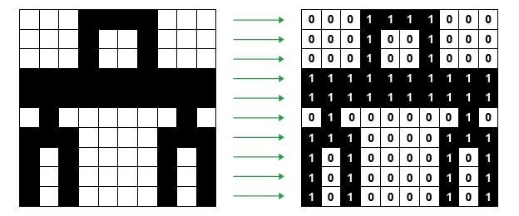

1. **BLACK AND WHITE IMAGE–** The image which consist of only black and white color is called BLACK AND WHITE IMAGE.

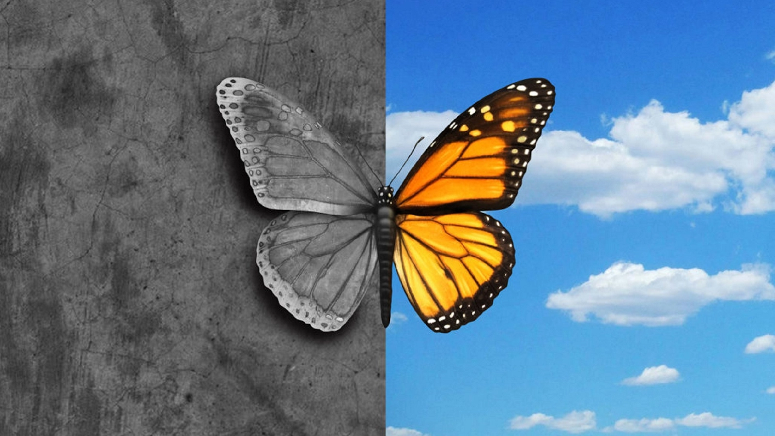

1. **8 bit COLOR FORMAT–** It is the most famous image format.It has 256 different shades of colors in it and commonly known as Grayscale Image. In this format, 0 stands for Black, and 255 stands for white, and 127 stands for gray.
2. **16 bit COLOR FORMAT–** It is a color image format. It has 65,536 different colors in it.It is also known as High Color Format. In this format the distribution of color is not as same as Grayscale image.

A 16 bit format is actually divided into three further formats which are Red, Green and Blue. That famous RGB format.

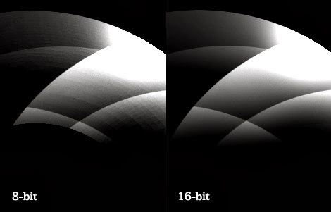

**2. What is Digital Image Processing?**

* Digital image processing generally refers to processing of a 2D picture by a digital computer.

**3. Write the Steps of Digital Image Processing?**

### 

### The fundamental steps in any typical Digital Image Processing pipeline are as follows:

### 1. Image Acquisition

### The image is captured by a camera and digitized (if the camera output is not digitized automatically) using an analogue-to-digital converter for further processing in a computer.

### 2. Image Enhancement

### In this step, the acquired image is manipulated to meet the requirements of the specific task for which the image will be used. Such techniques are primarily aimed at highlighting the hidden or important details in an image, like contrast and brightness adjustment, etc. Image enhancement is highly subjective in nature.

### 3. Image Restoration:

### This step deals with improving the appearance of an image and is an objective operation since the degradation of an image can be attributed to a mathematical or probabilistic model. For example, removing noise or blur from images.

### 4. Color Image Processing

### This step aims at handling the processing of colored images (16-bit RGB or RGBA images), for example, peforming color correction or color modeling in images.

### 5. Wavelets and Multi-Resolution Processing

### Wavelets are the building blocks for representing images in various degrees of resolution. Images subdivision successively into smaller regions for data compression and for pyramidal representation.

### 6. Image Compression

### For transferring images to other devices or due to computational storage constraints, images need to be compressed and cannot be kept at their original size. This is also important in displaying images over the internet; for example, on Google, a small thumbnail of an image is a highly compressed version of the original. Only when you click on the image is it shown in the original resolution. This process saves bandwidth on the servers.

### 7. Morphological Processing

### Image components that are useful in the representation and description of shape need to be extracted for further processing or downstream tasks. Morphological Processing provides the tools (which are essentially mathematical operations) to accomplish this. For example, erosion and dilation operations are used to sharpen and blur the edges of objects in an image, respectively.

### 8. Image Segmentation

### This step involves partitioning an image into different key parts to simplify and/or change the representation of an image into something that is more meaningful and easier to analyze. Image segmentation allows for computers to put attention on the more important parts of the image, discarding the rest, which enables automated systems to have improved performance.

### 9. Representation and Description

### Image segmentation procedures are generally followed by this step, where the task for representation is to decide whether the segmented region should be depicted as a boundary or a complete region. Description deals with extracting attributes that result in some quantitative information of interest or are basic for differentiating one class of objects from another.

### 10. Object Detection and Recognition

### After the objects are segmented from an image and the representation and description phases are complete, the automated system needs to assign a label to the object—to let the human users know what object has been detected, for example, “vehicle” or “person”, etc.

### **## Write the advantages and disadvantages of Digital Image Processing?**

### **Advantages of Digital Image Processing:**

1. Improved image quality: Digital image processing algorithms can improve the visual quality of images, making them clearer, sharper, and more informative.
2. Automated image-based tasks: Digital image processing can automate many image-based tasks, such as object recognition, pattern detection, and measurement.
3. Increased efficiency: Digital image processing algorithms can process images much faster than humans, making it possible to analyze large amounts of data in a short amount of time.
4. Increased accuracy: Digital image processing algorithms can provide more accurate results than humans, especially for tasks that require precise measurements or quantitative analysis.

### **Disadvantages of Digital Image Processing:**

1. High computational cost: Some digital image processing algorithms are computationally intensive and require significant computational resources.
2. Limited interpretability: Some digital image processing algorithms may produce results that are difficult for humans to interpret, especially for complex or sophisticated algorithms.
3. Dependence on quality of input: The quality of the output of digital image processing algorithms is highly dependent on the quality of the input images. Poor quality input images can result in poor quality output.
4. Limitations of algorithms: Digital image processing algorithms have limitations, such as the difficulty of recognizing objects in cluttered or poorly lit scenes, or the inability to recognize objects with significant deformations or occlusions.
5. Dependence on good training data: The performance of many digital image processing algorithms is dependent on the quality of the training data used to develop the algorithms. Poor quality training data can result in poor performance of the algorit

**# Write the** Applications of Digital Image Processing

## 1) Image sharpening and restoration

## 2) Medical Field

## 3) Robot vision

## 4) Pattern recognition

## 5) Video processing